1. User Requirements
1.1 Actors

# | Actor | Description
1 | Admin | Responsible for managing and operating the system. The Admin manages user accounts, assigns user roles, manages medicine and laboratory test catalogs, configures medical thresholds and system settings, monitors system activities, and views system statistics to ensure the system operates correctly, securely, and consistently.
2 | Patient | Interacts with the system to access and monitor personal health information. This includes viewing medical history, laboratory test results, diagnoses, doctor-provided risk assessments, electronic prescriptions, and receiving notifications for ongoing care and treatment.
3 | Doctor | Interacts with the system to manage patient care and clinical workflows. Key responsibilities include viewing patient medical histories, recording and updating diagnoses, ordering laboratory tests, reviewing test results, conducting risk assessments, issuing electronic prescriptions, and updating ongoing care and treatment plans.
4 | AI | The AI is an automated component responsible for organizing and presenting patient health data in a structured and accessible manner to support monitoring by medical staff. Key responsibilities include displaying patient medical records and laboratory test results, presenting vital sign data for easy tracking, showing diabetes risk indicators, providing diagnosis support reports generated by physicians, notifying medical staff of flagged health data, sending automated reminders to patients regarding appointments and medications, and responding to health-related queries through an interactive Chat Bot interface.

1.2 Use Cases

a. Diagram(s)
Admin:
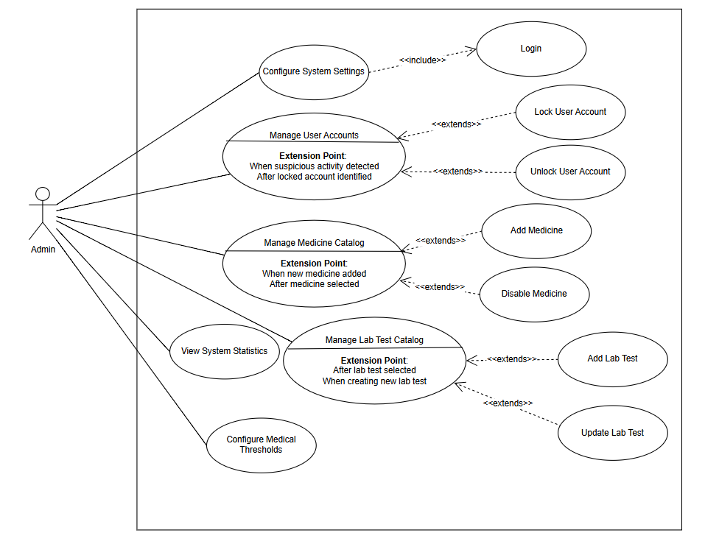

Patient:

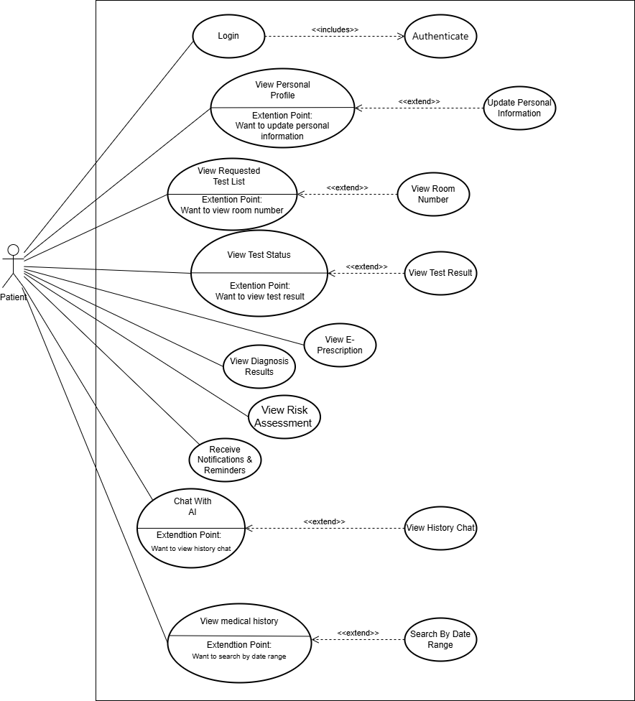

Doctor:

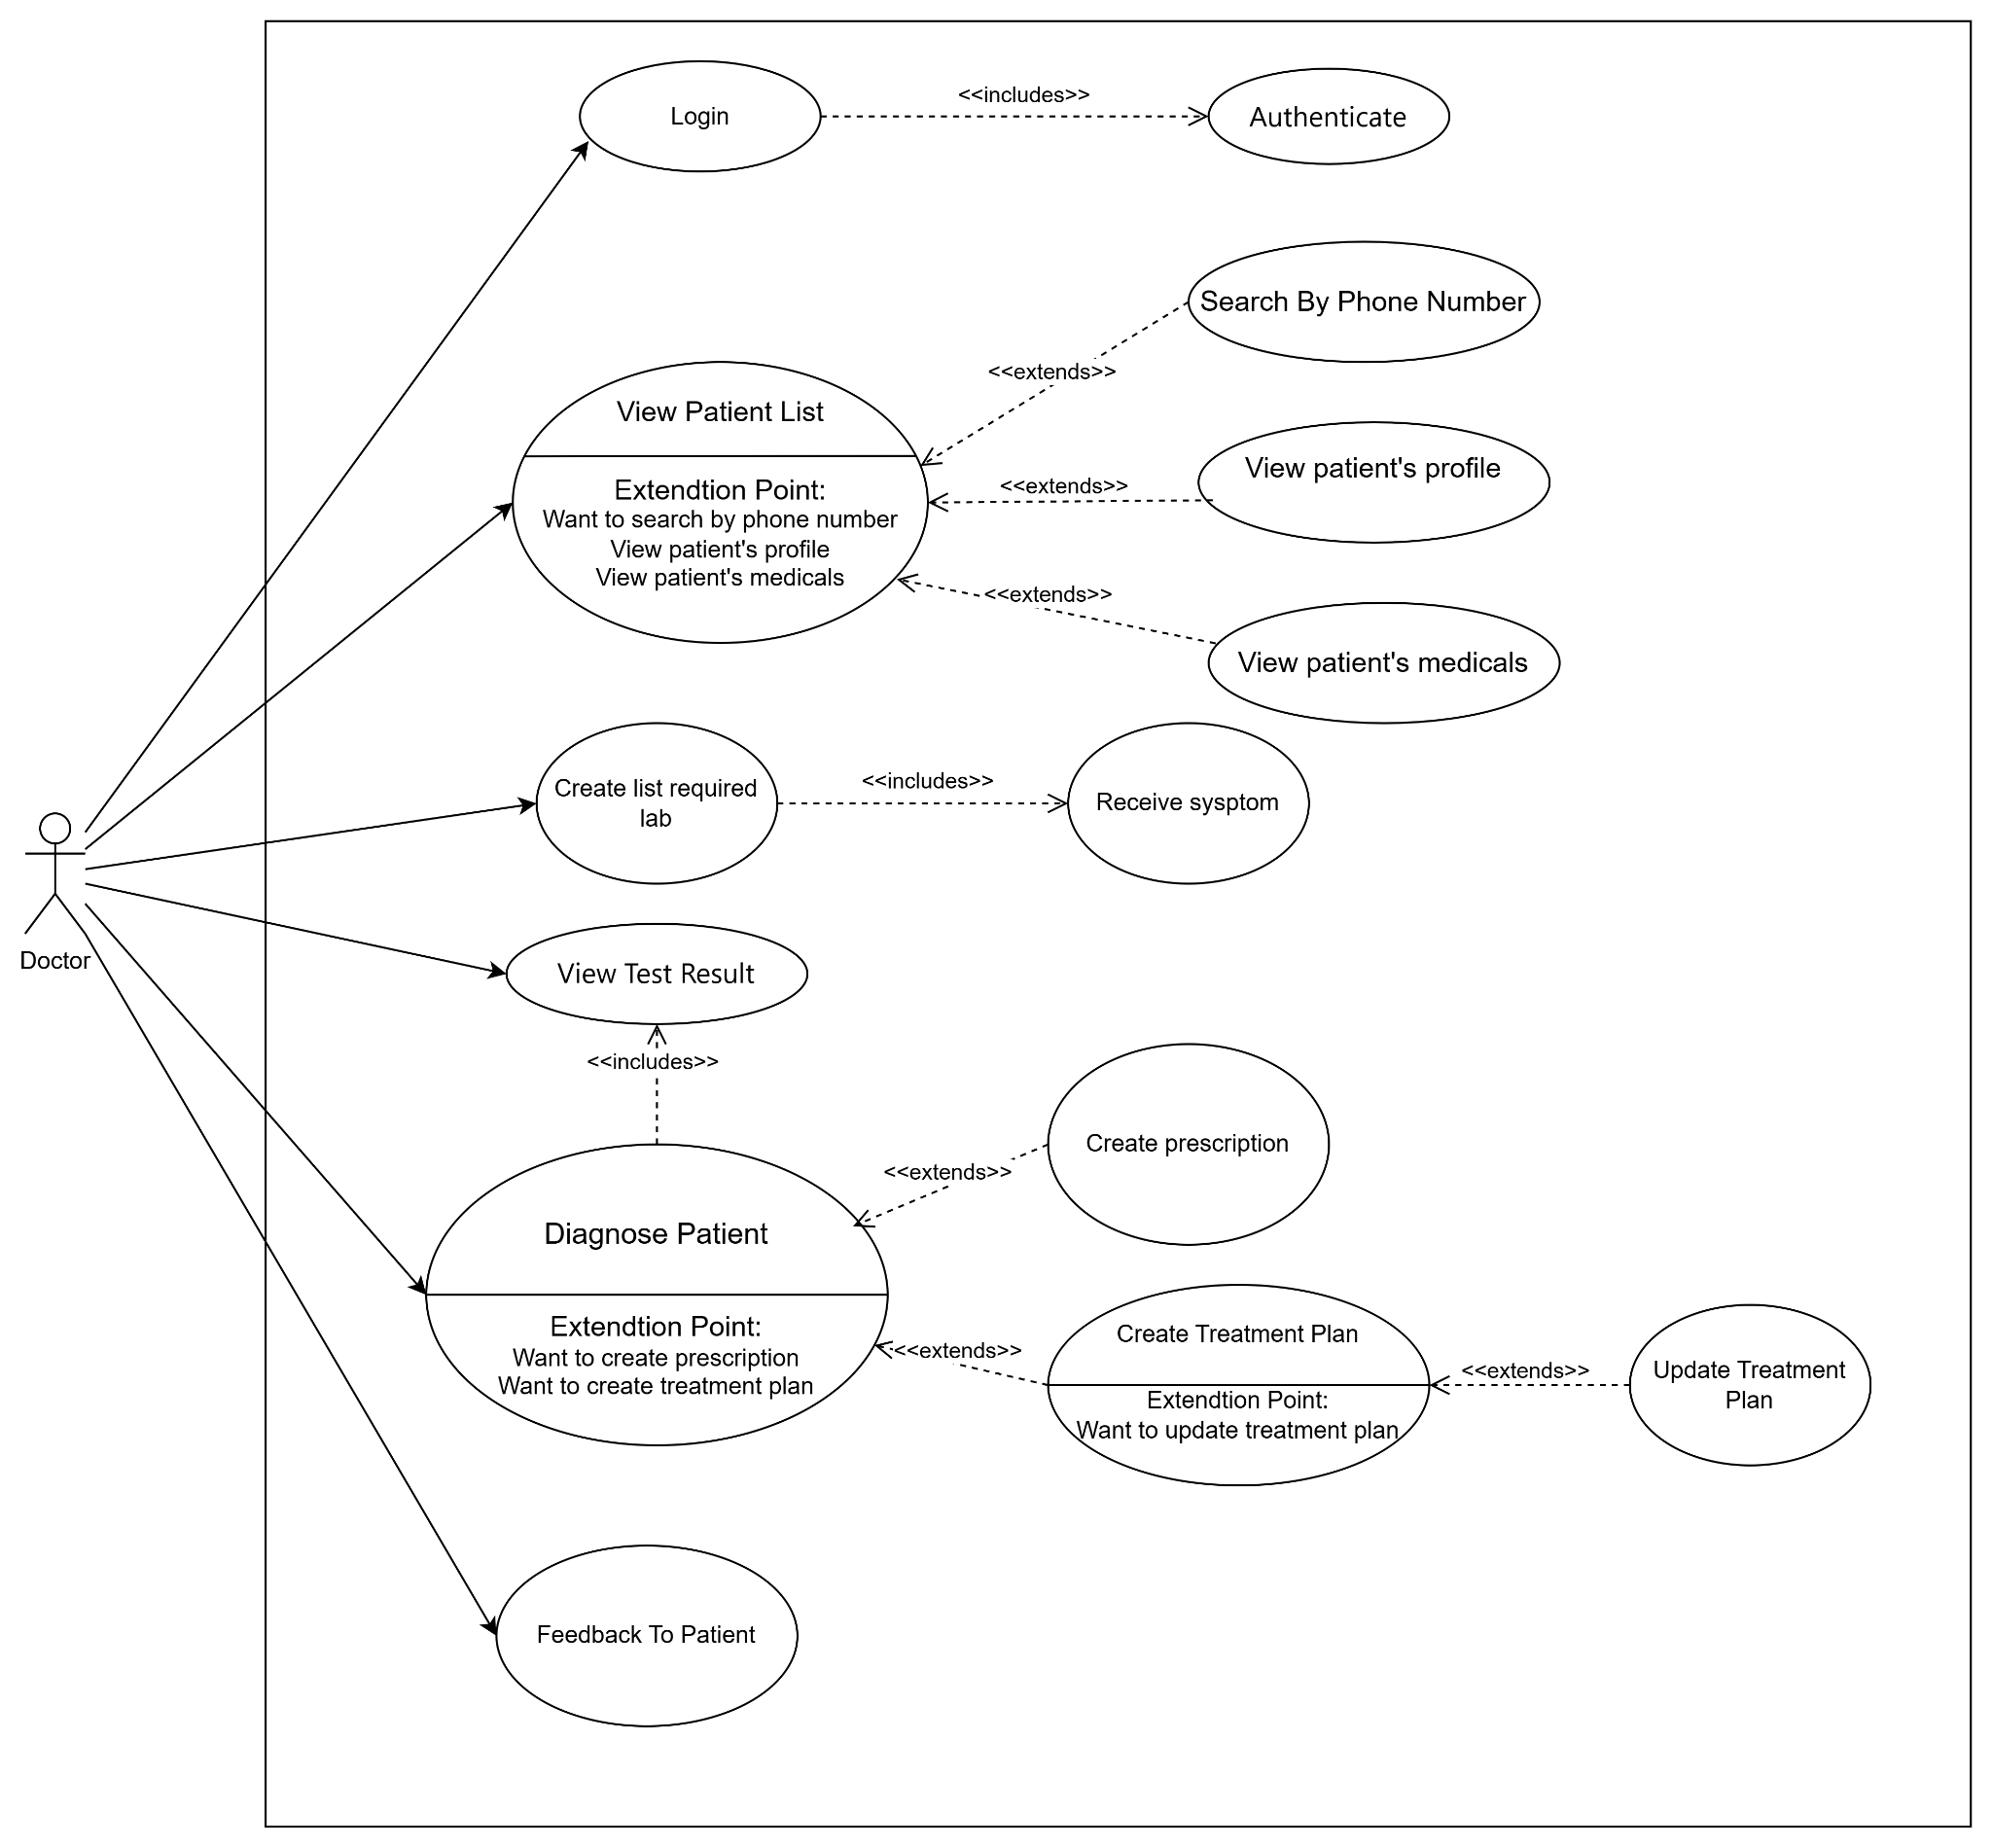

AI Assistant:

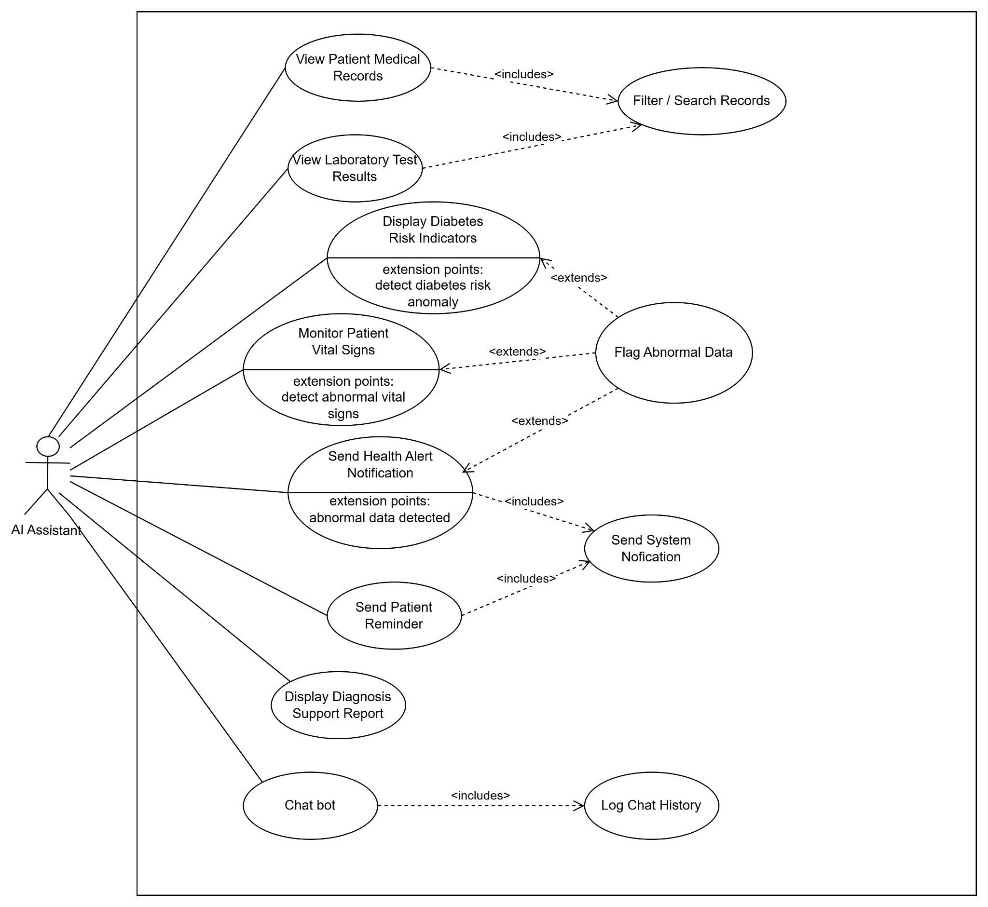

b. Descriptions

ID | Feature | Use Case | Main Actor | Use Case Description
 | System Access | Login | Admin | Admin logs into the system to perform administrative functions.
 | System Configuration | Configure System Settings | Admin | Admin configures general system settings and notification rules.
 | User Management | Manage User Accounts | Admin | Admin manages user accounts in the system.
 | User Management | Lock User Account | Admin | Admin locks a user account when suspicious activity is detected.
 | User Management | Unlock User Account | Admin | Admin unlocks a user account after verification.
 | Medicine Management | Manage Medicine Catalog | Admin | Admin manages medicine information in the system.
 | Medicine Management | Add Medicine | Admin | Admin adds new medicine information to the catalog.
 | Medicine Management | Disable Medicine | Admin | Admin disables medicines that are no longer in use.
 | Laboratory Test Management | Manage Lab Test Catalog | Admin | Admin manages laboratory test categories and information.
 | Laboratory Test Management | Add Lab Test | Admin | Admin adds a new laboratory test to the system.
 | Laboratory Test Management | Update Lab Test | Admin | Admin updates existing laboratory test information.
 | Medical Threshold Configuration | Configure Medical Thresholds | Admin | Admin configures medical thresholds for risk assessment and alerts.
 | System Monitoring | View System Statistics | Admin | Admin views system activity statistics and reports.
 | System Access | Login | Doctor | The doctor logs into the system to access medical functions.
 | System Access | Authenticate | Doctor | The system authenticates the doctor's login credentials.
 | Patient Management | View Patient List | Doctor | The doctor views a patient’s personal profile information.
 | Patient Search | Search By Phone Number | Doctor | The doctor searches for patients using phone numbers.
 | Patient Information | View Patient Profile | Doctor | The doctor views a patient’s personal profile information.
 | Medical Record Management | View Patient Medical Records | Doctor | The doctor views patient medical history and records.
 | Laboratory Request | Create Required Lab Test List | Doctor | The doctor creates a list of required laboratory tests for a patient.
 | System Response | Receive System Response | Doctor | The doctor receives confirmation or responses from the system after creating test requests.
 | Test Result Management | View Test Result | Doctor | The doctor views the patient 's laboratory test results.
 | Diagnosis | Diagnose Patient | Doctor | A doctor diagnoses a patient based on medical information and test results.
 | Prescription Management | Create Prescription | Doctor | The doctor creates a prescription for the patient.
 | Treatment Plan Management | Create Treatment Plan | Doctor | The doctor creates a treatment plan for the patient.
 | Treatment Plan Management | Update Treatment Plan | Doctor | The doctor updates an existing treatment plan when necessary.
 | Patient Communication | Feedback To Patient | Doctor | The doctor provides feedback or consultation information to the patient.
 | System Access | Login | Patient | Patients log into the system to access personal healthcare information.
 | System Access | Authenticate | Patient | The system authenticates the patient’s login credentials.
 | Profile Management | View Personal Profile | Patient | Patient views personal profile information.
 | Profile Management | Update Personal Information | Patient | Patients update personal information when necessary.
 | Laboratory Request | View Requested Test List | Patient | The patient views the list of requested laboratory tests.
 | Laboratory Request | View Room Number | Patient | The patient views the assigned room number for laboratory tests.
 | Test Tracking | View Test Status | Patient | The patient tracks the status of laboratory tests.
 | Test Result Management | View Test Result | Patient | Patient views laboratory test results.
 | Diagnosis Result | View Diagnosis Results | Patient | The patient views diagnosis results provided by the doctor.
 | Prescription Management | View E-Prescription | Patient | The patient views electronic prescriptions issued by the doctor.
 | Risk Assessment | View Risk Assessment | Patient | Patient views healthcare risk assessment results.
 | Notification Management | Receive Notifications & Reminders | Patient | The patient receives notifications and reminders from the system.
 | AI Support | Chat With AI | Patient | The patient interacts with the AI chatbot for healthcare support.
 | Chat History | View Chat History | Patient | Patient views previous chatbot conversation history.
 | Medical History | View Medical History | Patient | Patient views medical history and previous healthcare records.
 | Medical History Search | Search By Date Range | Patient | The patient searches medical history by date range.
 | Medical Record Management | View Patient Medical Records | AI Assistant | AI Assistant retrieves and displays patient medical records.
 | Record Search | Filter / Search Records | AI Assistant | AI Assistant filters and searches patient records and laboratory results.
 | Laboratory Result Analysis | View Laboratory Test Results | AI Assistant | AI Assistant analyzes and displays laboratory test results.
 | Risk Assessment | Display Diabetes Risk Indicators | AI Assistant | AI Assistant displays diabetes risk indicators for patients.
 | Abnormal Data Detection | Flag Abnormal Data | AI Assistant | AI Assistant detects and flags abnormal healthcare data.
 | Vital Sign Monitoring | Monitor Patient Vital Signs | AI Assistant | AI Assistant monitors patient vital signs continuously.
 | Health Alert Management | Send Health Alert Notification | AI Assistant | AI Assistant sends health alert notifications when abnormal conditions are detected.
 | Reminder Management | Send Patient Reminder | AI Assistant | AI Assistant sends reminders for appointments, medication, or laboratory tests.
 | Notification Management | Send System Notification | AI Assistant | AI Assistant sends system notifications to users.
 | Diagnosis Support | Display Diagnosis Support Report | AI Assistant | AI Assistant displays diagnosis support reports for doctors and healthcare staff.
 | AI Communication | Chat Bot | AI Assistant | AI Assistant communicates with users through a chatbot interface.
 | Chat History Management | Log Chat History | AI Assistant | AI Assistant stores chatbot conversation history for future reference.

Context Diagram

